Artificial Intelligence
Excercise II
Dawid Sitnik
ID: 2016 1183 76

1.Intelligent Agent
Intelligent agent, in artificial intelligence is an independent entity which is achieving some goals. It acts in some environment and uses sensors and actuators. It doesn’t have to know how to fulfill his task from the beginning of its work. It can use its knowledge or learn during the activity. It can be very simple or complex. The washing machine can be an example of intelligent agent.

Intelligent agents are usually compared to the abstract system, similar to computer program. For that reason, we usually call them abstract intelligent agents, because we want to make a distinction between them and their real world implementations as computer systems, biological systems and organizations. Some definitions focus on their independence calling them autonomous intelligent agents. Some other descriptions consider goal-directed behavior as the essence of intelligent agent, calling them rational agents.

Agents in economics are closely related to this one from artificial intelligence. Versions of IA paradigm are studied in cognitive science, ethics, the philosophy of practical reason, but also in many interdisciplinary socio-cognitive modeling and computer simulations of the society.

Intelligent agents are also close relatives to software agents, which are autonomous computer programs which carries out tasks instead of user. In computer science, even though an intelligent agent is not the same as one from Norvig’s definitions, it can still be described as software agent with some intelligence. For example, in data science, we frequently uses bots who are autonomous programs and we also call them intelligent agents.

Russell & Norvig grouped intelligent agents into five groups based on the complexity of predictions and their possibilities. This groups are:

1. Simple reflex agents
2. Model-based reflex agents
3. Goal-based agents
4. Utility-based agents
5. Learning agents

1.1 Simple reflex agent
This one is the simplest type of agent. It ignores many conditions of environment, simplifying it. It is based on the base if statement: “if something than do something”. To work properly, its environment has to be fully observable. Somehow it can has a simple memory which will make him skipping taking conditions which actuators are already on. Programming this type of agent it is hard to avoid infinite loops, however it is possible if we will randomize some actions.
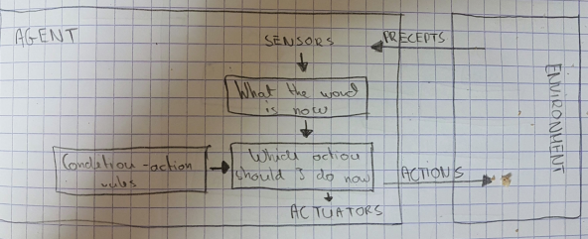

1.2 Model-based reflex agent
This type of model seems to be the most efficient way to act in partially described environment. It should maintain some sort of internal model that depends on the percept history and thereby reflects at least some of the unobserved aspects of the current state. It means the agent has its own model of the world that can not be seen. This model is made of some projects of the world which are based on some observable predictions of the world.

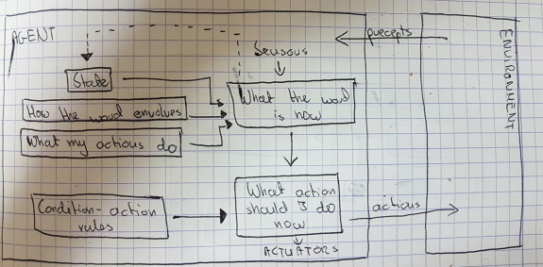

1.3 Goal-based agent
Knowing just a current state of environment is usually not enough. Even if we know where we are, we need to know where we want to go in case to make any decision. For example when we are on the crossing, we will not be able to make a decision where to go, unless we know where we want to be. So goal-based agent makes decision to achieve its goal. This agent can be combined with reflex agent which will help with describing current state of the agent.
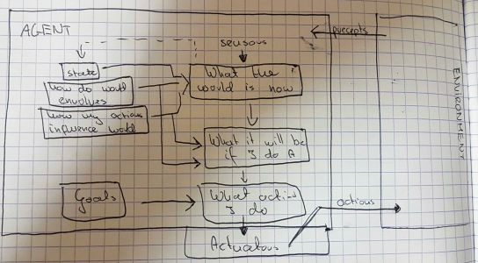

1.4 Utility-based agents
This agent is able to determine how desirable a particular state is. This measure can be obtained through the use of a utility function which maps a state to a measure of the utility of the state. In other words it describes how much happiness will be given to the agent while obtaining particular state. The happier agent is, it is better.

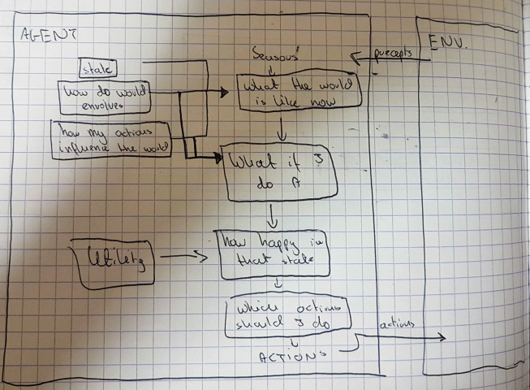

1.5 Learning agent
Learning agent doesn’t need to have too much information about its environment. It learns while processing. It uses input data, convert it through the function and gives an output. The most important distinction is between the "learning element", which is responsible for making improvements, and the "performance element", which is responsible for selecting external actions. The feedback element use a knowledge from “critic” to improve its actions. After each iteration it becomes learns more, becoming better and better by the time. The performance element is the same as entire agent in the previous examples. There is also one more component in this agent which is called “problem generator”. It proposes actions which will lead new and informative experience.
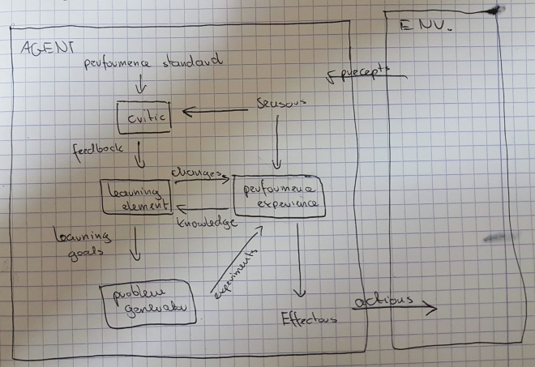

2. Description of agent from previous exercise:
While making the previous exercise I have also implemented some kind of DFS algorithm. The difference was that we didn’t know the graph so we had to try every possibility. My solution to the maze problem was to try to move in every possible direction. If turtle was possible to move it moved, if not, it remembered in which direction it already moved and didn’t try the same once again. If it was in cul-de-sac it was coming back to the place with other possible road, deleting the last element from the stack. In this way I was possible to check every possible road and get out of the maze.

The only enchantment which came to my mind was to prepare the turtle for the situation in which we can go around the maze. To do that I would just need to get coordinates of each place in the maze and mark them as visited to avoid making the circle. However, it was easy to fix so I decided to create a new problem for myself.

3. Description of my new agent:
The purpose of our agent is to go through the city (from one point to another) in a way that meets our expectations. In a situation when we came to new city, wanting to do as much as we can, we always have to face the same problem – planning our trip. While making a plan we have to consider many aspects: cost, eating, sleeping, monuments, attractions, transportation, our condition and time. We need to decide if eating cheaper but taking a longer walk is satisfying enough for us, or maybe it is better to take a taxi and go to the most expensive place. The agent will have to make this decision based on personal preferences. If we will say we don’t have a big budget, we are in a good condition and we like to party, the agent will try to look for few most important monuments which are less expensive and will show us a walking way from one point to another. It will plan our evening to find the best party for us which will also be next to our hostel.

This agent will have to be a utility based agent which means it will make decision based on our utility. We can imagine our utility as preferences of the user. Lets say we are a student who doesn’t have too much money, prefer walking than public transport and instead of just sight seeing, he also wants to party a little bit. In that case we will have to make a trip plan based on his preferences. We will try to find a path which makes our user as much happy as it is possible.

The goal of that agent is to spend as much time outside as possible going from one point to another. I will also have to satisfy our user. In that case our model is a city plan which we already know (we can check it on the map or in the Internet). We will try to describe this plan as a graph, where monuments are nodes, and roads are edges of the graph. Every edge should have its own values of the time that it takes to traverse the path, but also a special ratio which describe how this path will satisfy the user.

4. How to solve that problem?
The idea is to find the best path from one point to another, where the best means that one which meets our requirements. We should find all possible paths and than decide which one fits the best. We can imagine plan of the city as a graph where places (monuments, restaurants etc) are nodes and roads are edges. We will check all possible paths from one point to another. The important thing is that we have to remember paths, its costs and also the time which it takes. If any path will exceed our time we will need to exclude it. At the end of execution we should get a list of possible paths (which doesn’t exceed maximum time) with its costs and proximate times. After seeing the list of the path we will need to decide which one is the best one for us.

The cost of the path should be determined taking into account our preferences. While calculating this ratio we should consider distance, price, popularity of the place etc. While programming my graph I am not going to include this part. As the purpose of the exercise is to understand graphs theory I am going to focus on path searching and I will put random values to costs.

To traverse the graph we are going to use recursive DFS algorithm. While traversing we need to note our path to be able to follow it again. We should also remember the time and cost to decide which path will be the best for us. Now the question is how to do it. The idea is to do recursive Depth First Traversal of given not directed graph. Start the traversal from source. Keep storing the visited nodes in an array ‘path[]’. If we reach the destination vertex, print contents of path[]. The important thing is to mark current vertices in path[] as visited also, so that the traversal doesn’t go in a cycle.

At this picture we can see the most important part of the algorithm. For all neighbors of the node we are checking if it was already visited. If not, we are appending our cost and time lists of new values and executing the same function, but with changed arguments. Now instead of start we put the name of the neighbor city, and instead of empty path, we put our old one.
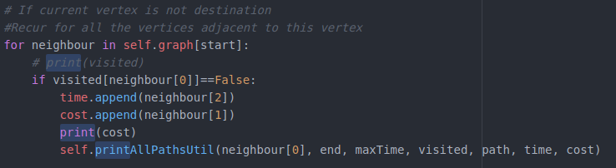

For better explanation lets consider graph from example:

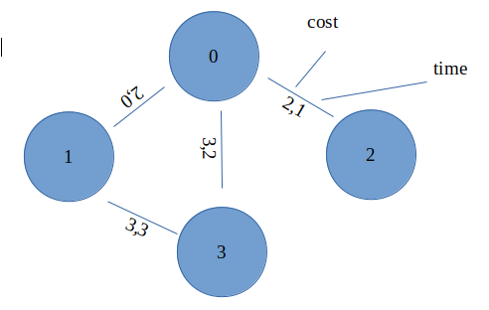
1,4

Lets say we are starting at node 2 and want to go to node 3. First of all, we are adding node 2 to the path and marking him as visited. Than we are adding edge cost and time to its lists and execute our function again for all its neighbors BUT only if they weren’t visited yet (we don’t want to create cycles). If we will find our ending node, we are displaying the path with its cost and time, and starting looking from new path. To do this we need to remove the last node from the path and try to go in different direction. We are doing the same until we try all possible paths.

In this particular case our “path” will look like this after each iteration:

0. [ 2 ]
1. [ 2,0 ]
2. [ 2,0,1 ]
3. [ 2,0,1,3 ](first path)
4. [ 2,0,1 ]
5. [ 2,0 ]
6. [ 2,0,3 ](second path)
7. [ 2,0 ]
8. [ 2 ]
9. [ 2,1 ]
10. [ 2,1,0 ]
11. [ 2,1,0,3 ](third path)
12. [ 2,1, 0 ]
13. [ 2,1 ]
14. [ 2,1,3 ] (fourth path)
For better visualization there are pictures of first few executions:

1.
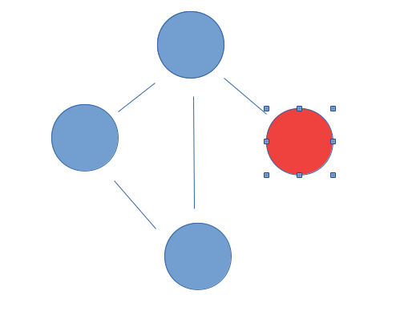
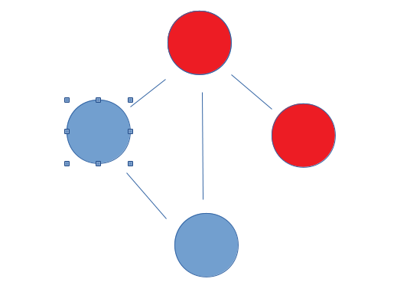
2.

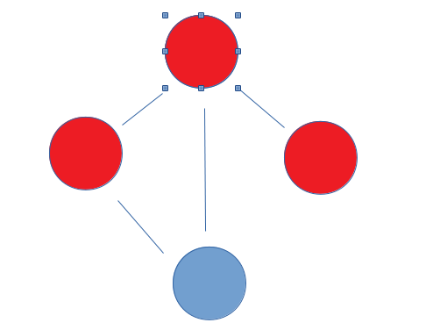
3.
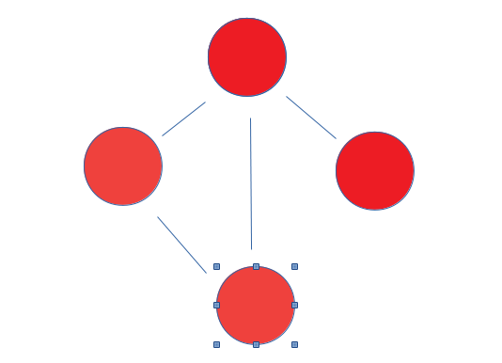
4.

5.

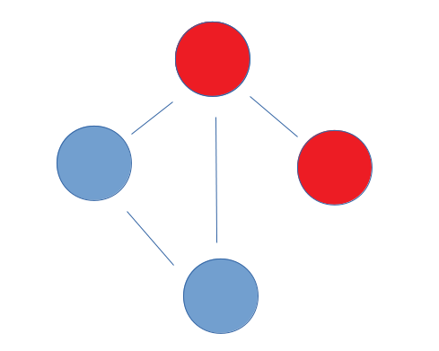

6.

7.
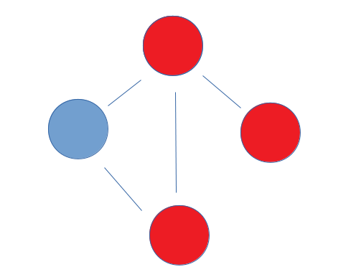
8.

9.
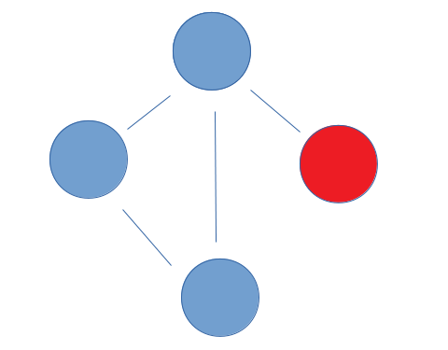
It will be analogical for cost and time lists as well.

Another thing which we should consider is how to create a graph. It will be described as list of lists. The main list is a list of nodes and every sublist will be neighbors of that node. To describe a neighbor one value is not be enough so I have made a class called Edge. So every sublist will be a list of arrays with three values: cost, time, and the city that the road leads to.

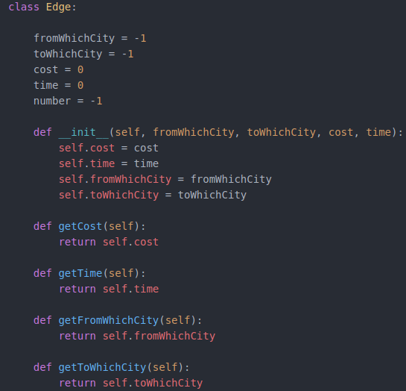

As we can see on the picture, the class is described by the city that it comes from, the city which it is going to, it cost (random value, I am skipping part of calculations based on user preferences) and time. We also need getters to be able to use this values.

To create a graph we use function called addEdge().
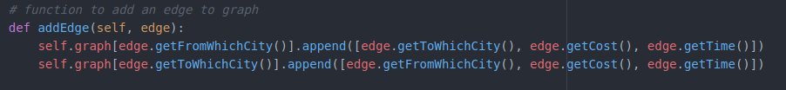

To the list of index edge.getFromWhichCity() we are adding array of three values which are city that we can go to and cost and time of the edge. As the graph is not directed we are doing it for the node that is at the opposite side too, but with changed vales. Now instead of adding edge.getFromWhichCity(), we are using edge.getToWhichCity(), because we are on the opposite side of the edge.

And in this part we are creating edges and adding them to the graph. As we can see Edge(0, 1, 2, 3) will create an edge which starts in city 0 and finishes in city 1. The cost of the path will be 2 and the time to traverse that path will be 3. The same edge will be added to the list with index 1 (city 1), but with values (1, 0, 2, 3)

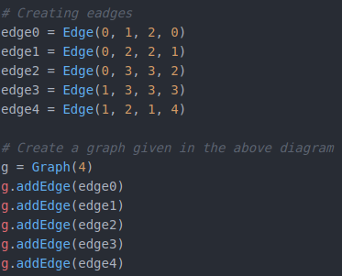
And this is actual output from the program:

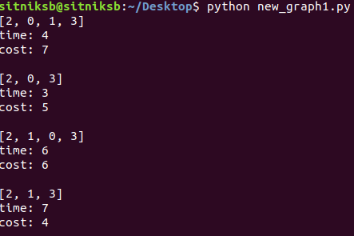
The first line of output is the first path (for now, name of cities are represented as numbers), the second is the sum of times and the third is sum of costs. We are getting all possible paths which doesn’t exceed our maxTime (which is defined in the program as 16 for now). Having all that informations we can chose a path which fits our expectations the best.

5. How can I improve my agent

There are few fixes which cones to my mind while thinking about improving this agent. After traversing all paths I am displaying all possible roads. I decided to do that, because I wanted user to have a choice. I didn’t want to propose just one solution. It can cause a problems when the graph is bigger, but that can be fixed with only one if, so I am leaving it as it is for now.

Another thing is that I am skipping the part of calculating the cost of the edge. To to that I should create a formula which takes into account users preferences and returns a numerical value. I have skipped this part because it is not the purpose of the exercise.

6. Resources:
https://en.wikipedia.org/wiki/Intelligent_agent

https://www.google.com/search?q=artificial+intelligence+modern+approach&oq=artificial+intelliegnce+mode&aqs=chrome.1.69i57j0l5.5339j0j7&sourceid=chrome&ie=UTF-8

https://www.geeksforgeeks.org/depth-first-search-or-dfs-for-a-graph/

https://eduinf.waw.pl/inf/alg/001_search/0125.php

